Harassment, Discrimination, and Non-Fraternization Curriculum for Undergraduate Research Opportunities
Version 0.2 - Last Update: June 14, 2018

Contributors: Michael Hubenthal¹, Daphne Ladue², Martin Snow³
¹IRIS Consortium, ²University of Oklahoma, ³University of Colorado, Boulder

Audience: Undergraduate students participating in a science, technology, engineering, or math
summer research opportunity.

Time:
Session 1 - ~75 minutes
Session 2 - 30 to 60 minutes

Learning Objectives:
Following instruction, participants will be able to:
- Describe a work environment that
  - consists of mutual respect
  - promotes respectful and congenial relationships
  - is free from all forms of harassment and discrimination
- Summarize who is responsible for creating the work environment described above
- Distinguish between behavior that is harassing or discriminating and non-harassing or discriminating
- Describe the program’s investigation procedures and possible disciplinary outcomes
- Plan how they would respond to incidents of discrimination or harassment including sexual harassment
- Apply the program’s non-fraternization policy to a series of case studies.

Materials
- One copy the Program handbook outlining the program’s anti-harassment and non-fraternization policies for each participant (references below are to the IRIS Undergraduate Internship Handbook).
- One copy of the Clancy et al., 2014 paper for each participant.
- http://www.voxvote.com or other anonymous polling software prepared with the following question.
Which of the following most closely to applies to you?
- a. Never witnessed discrimination and never heard of of someone who experienced it
- b. Heard of someone who experienced discrimination but never witnessed it
- c. Witnessed discrimination
- d. Experience discrimination
- For every 6 to 8 people (teams of 3 to 4)
  - One large flip chart(s) and markers
  - Pack of “Pictionary” cards. Print and cut out cards from Appendix B.
- Pack of small group discussion questions . Print and cut out from Appendix C. Assuming groups of 2 to 3, one pack will work for up to 21 participants.

Instructional Flow - See Appendix A for description of lesson structure.
Open - (8 to 10 Minutes)

- Step 1: Divide students up into small group of 3 or 4.

- Step 2: Distribute the Clancy et al., 2014 paper (reference below). Ask participants to turn to figure 3 (shown below) and reflect on and discuss within their group.
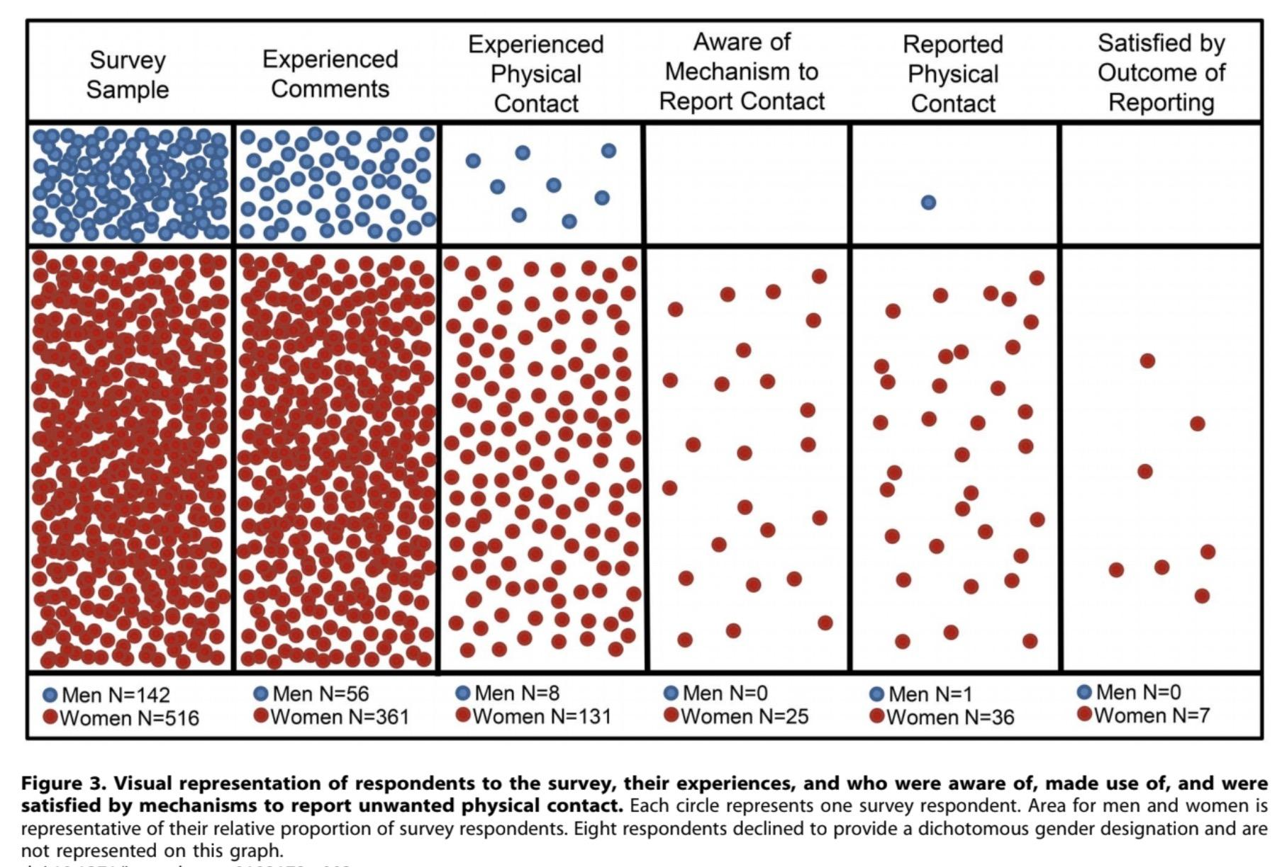
- Step 3: Solicit participants reactions* to the data and
  - As a program we are concerned by the numbers of participants (both men and women)
    - who had experienced sexual harassment, and
    - the small numbers of participants who were aware of the mechanism to report.
  - Note that while this paper deals with sexual harassment, we are committed to a zero tolerance policy for all harassment and discrimination.
*As a facilitator you should be aware of study limitations outlined on page 3 of the paper..

- Using an anonymous polling software (e.g. http://www.voxvote.com or other) to ask students the following to illustrate that the concept of discrimination is not a theoretical construct represented in an article or handbook.
Which of the following most closely to applies to you?
- a. Never witnessed discrimination and never heard of of someone who experienced it
- b. Heard of someone who experienced discrimination but never witnessed it
- c. Witnessed discrimination
- d. Experience discrimination

- Indicate that our goal, through this module is to protect our participants and to take action to make a cultural change.

- Review the goals (described above) for this lesson with the participants.

Prior Knowledge - Keyword Pictionary (20 - 22 Minutes)

Step 1: Divide students into even teams of 4 or 5

Step 2: Assign one person from each team to be the first “drawer”. The drawer will have 10 second to look at the word on the card before beginning to draw.

Step 3: Select one team to go first.

Step 4: Hand the “drawer” a card with the term on it. They will have 10 seconds to look at the card and think followed immediately by 1 minute to “draw” the word on the card without using written or verbal words/numbers, or gestures.

Step 5: Non-drawing students from the team will watch and “guess” what the term is based on the drawing. Other teams not participating watch. The play is over when the 1 minute runs out or the term is guessed

Step 5: Repeat steps 4 & 5 with a drawer from another team.

Step 6: The game continues until all terms have been drawn.

Step 7: Once the game is over, divide up the cards between the groups and ask each group to use chart paper to develop a consensus definition* for each of their cards.

*A consensus definition is a decision achieved through negotiation whereby a hybrid resolution is arrived on an issue, dispute or disagreement, comprising typically of concessions made by all parties, and to which all parties then subscribe unanimously as an acceptable resolution.

Explore/Explain - (35 Minutes)

Step 1: Ask each group to report out their vocabulary and introduce their ideas for each term. Facilitate a whole group discussion to clarify and refine terminology accepting ideas from all participants but steering final revisions towards generally accepted vocabulary and to distinguish between behavior that is harassing or discriminating and non-harassing or discriminating behavior. (HB page 4)

Step 2: Add the following terms to the list and accept ideas from the group to help define.
- Hostile work environment
- Quid pro quo
- Retaliation

Step 3: Note where harassment is covered in the internship handbook (pages 3 to 6). Assign participants to read these pages.

Step 4: Divide the class into smaller groups (e.g. 3-4) and give each group a discussion question and ask them to read the question and discuss the scenario in light of the handbook.

Step 5: After all groups have discussed their question, ask a representative of the group to share the question and briefly summarize the key points of the groups discussion.

Step 6: As a whole group, describe the complaint procedure and outline program’s investigation procedures and possible disciplinary outcomes

Reflect - Why does this matter and what is your role? (5 Minutes)

Step 1: Ask student to envision what sorts of benefits might be derived from a
work environment that consists of mutual respect, promotes respectful and congenial relationships and is free from all forms of harassment and discrimination vs one that is not?

Step 2: Ask students who is responsible for creating the work environment (HB page 6)
- Who are the actors responsible for creating such an environment?
- In what way does each actor contribute?

Apply - Case study discussion (30 - 60 MInutes on a different day)

Short version -

Step 1: Assign students to read the “A Quick Wink” case study as homework.
Step 2: The next time the group is together, ask students, working in small groups, to analyze the case study in light of the policies outlined in the programs handbook. They should look for places where the policies in the handbook are relevant to the actions and interactions between the characters. Pay particular attention to the complaint procedure questions to ensure students understand what actions they should take if they see or experience harassment of any kind.

Discussion topics | Handbook Page(s)
What is our program’s alcohol policy? Does it apply to this case? If so, how? | 3
What is our program’s non-fraternization policy? How might it apply to this case? | 6
What is sexual harassment? In what ways, might the actions of the faculty member be construed as sexual harassment? | 5
Who is responsible for assuring that a workplace is free of harassment (of any kind) or discrimination? What is Myrna’s responsibility? What about Jodie? How about Dr. Paige? | 6
What is the complaint procedure? What actions, if any should Myrna take? | 4
How does this case study facilitate a connection between the material of the case and real-life use?

Longer version - If time allows, have students create their own case studies. You will need to consider how will you implement the cases and select an appropriate methodology (e.g. a simulation, reading, role playing, longitudinal with increasing detail over time, etc.).

Step 1: Divide the students into small groups (e.g. 3 or 4).
Step 2: Before beginning to write actual scenarios (students will all want to begin with creating the scenario), students should first consider the following questions that will help them construct the foundation for the scenario.
- What are the learning objectives?
- What kinds of interactions are wanted between characters in the case, and learners during the teaching of the case?
- What points will be ambiguous in the case?
- Choose a setting for the case.
- Choose characters that are identifiable. They must seem real.
- Use learning objectives to create discussion questions.

Remind students that good cases have the following characteristics:
- They are contextual… a story situated in the environment you work in. Context allows for application of knowledge and expanding that knowledge.
- They have a narrative. The story engages the learner (attention, emotion)
- They are concrete
- They can be open-ended

Step 3: Provide time for students to “present” (this will vary by the type case they were to create) their cases to two to other groups. Following the “presentation” the presenting group should facilitate a discussion of the case using the following questions as a guide.

Sample discussion questions for use after student’s cases are presented.

- What was the role of <each character> in the case?
- What skills did the characters use or develop during the case?
- What was the outcome of the case?
- What else could have happened and why? What other course of action or consequences would have resulted?
- How did the case study facilitate a connection between the material and real-life use?
- How did <key characters> interact with <other character(s)>?
- How did the <characters> interact among themselves?
- What resources did the characters call upon to solve the problems in the case?
- How did interactions between characters affect how everyone was thinking about what happened in the case (knowledge translation from theory to practice)?

Microaggressions
https://sph.umn.edu/site/docs/hewg/microaggressions.pdf

References:
Anderson, J., Brown, G., Evans, J., Sankovich, E., Sims, J. (2009). Sexual Harassment- Prevention in Schools: A Facilitator's Manual and Curriculum for Grades 1 through 12. Retrieved from: http://www.pcar.org/resource/sexual-harassment-prevention-schools-facilitators-manual-and-curriculum-grades-1-through-12

Clancy, K. B., Nelson, R., Rutherford, J. N., Hinde, K. (2014). Survey of Academic Field Experiences (SAFE): Trainees Report Harassment and Assault. PLOS ONE. 9(7), e102172. https://doi.org/10.1371/journal.pone.0102172

Appendix A: OPERA Learning Cycle

A learning cycle is a model of instruction based on learning from experience. Learning cycles have been shown to be effective at enhancing learning by providing students with opportunities to develop their own understanding of a concept, explore and deepen that understanding, and then apply the concept to new situations. A number of different learning cycles have been developed. However, all are closely related to one another conceptually, and differ primarily in the number of steps the cycle is broken into.

This lesson is designed around a learning cycle that can be remembered as O-P-E-R-A. OPERA is convenient when designing lesson-level instruction because one can generally incorporate all the major components into the single experience. Each phase of the OPERA cycle is briefly outlined below.

 | Instructional Stage
Open | Open the lesson with something that captures students’ attention. This is an invitation for learning and leaves students wanting to know more.
Prior  Knowledge | Assess students’ Prior Knowledge and employ strategies that make this prior knowledge explicit to both the instructor and the learner.
Explore/Explain | Plan and implement a minds-on experience for students to Explore the content followed by Explanation
Reflect | Reflect on the concepts the students have been exploring. Students verbalize their conceptual understanding or demonstrate new skills and behaviors. Teachers introduce formal terms, definitions, and explanations for concepts, processes, skills, or behaviors.
Apply | Enable students to practice concepts, skills and behaviors by Applying the knowledge gained in a novel situation to extend students’ conceptual understanding.

Appendix B: Pictionary Cards - Print and cut out along edges
Harassment | Illegal
Flirting | Mutual respect
Unwanted | Investigation
Joke | Discrimination
Wanted | Power

Appendix C: Small Group Discussion Questions- Print and cut along dotted lines
-------------------------------------------------------------------------------------------------------------------------------

Q1 - Mike, has decided to go back to graduate school after having worked in industry for 15 years. Several of the other students in the labs have take to calling Mike “Pops”. Mike laughed at first but now it makes him uncomfortable. Is this harassment?
- Yes
- No
Why do you think so? How would you respond in this situation?

-------------------------------------------------------------------------------------------------------------------------------

Q2 - A grad student, Sosha, often overhears her female colleagues talking about the intimate details of their dating life and it makes her uncomfortable. Could this be considered harassment?
- Yes, the conversations are creating an offensive work environment
- No, the employee was not part of the conversation and therefore was none of her business
Why do you think so? What if this was a faculty member? How would you respond in this situation?

-------------------------------------------------------------------------------------------------------------------------------

Q3 - Charles asks out a fellow graduate student out on a dinner date. Is this considered harassment?
- Yes
- No
Why do you think so? When could this become harassment? What if they were a more senior student in the lab? What if your advisor asked you out? How would you respond in this situation?

-------------------------------------------------------------------------------------------------------------------------------

Q4 - Harassment can not be perpetrated by non-program participants or employees?
- Yes
- No
Why do you think so? Who else could be involved, especially as part of field experiments (other students from other universities, contractors, etc)? How would you respond in this situation?

Small Group Discussion Questions (Continued) - Print and cut along dotted lines
-------------------------------------------------------------------------------------------------------------------------------

Q5 - Jose is constantly leering at Derek, intentionally bumping into and brushing up against him. This make Derek feel uncomfortable. This is an example of what category of sexual harassment?
- Hostile work environment
- Quid pro quo
- Retaliation
- Not a violation
Why do you think so? How would you respond to this situation?

-------------------------------------------------------------------------------------------------------------------------------

Q6. An employee who files a harassment complaint can rest assured that the complaint will be kept completely confidential (e.g no one will be told about the complaint).
- Yes
- No
Why do you think so?

-------------------------------------------------------------------------------------------------------------------------------

Q7. Can an individual be found guilty of harassment even if they did not intend to harass the compaintant?
- Yes
- No
Why do you think so?

-------------------------------------------------------------------------------------------------------------------------------

Small Group Discussion Question Discussion Key
Question | Key points | Handbook Page(s)
Q1 | Since Mike considers the comments no longer funny, the do not promotes respectful and congenial relationships between individuals and may hostile or offensive working environment. Harassment may include, among many other things, age. | 4
Q2 | Harassment is based on the condition of being “un-welcomed” by another party, which does not involve the intent of the alleged harasser. Therefore, if Sosha finds herself uncomfortable, her female colleagues’ conversations may contributing to a hostile or offensive working environment, even if they had not intended it. | 4
Q3 | Asking someone out once does not constitute sexual harassment as long as submission is not an explicit or implicit term or condition of employment or the conduct does not unreasonably interfere with an individual's work performance or creates an intimidating, hostile or offensive working environment.  However, if the grad student declines, and Charles were to continue to ask the student out, it may become harassment by creating a hostile work environment. | 4
Q4 | The IRIS Internship Program encourages a working environment that consists of mutual respect, promotes respectful and congenial relationships between individuals, and that is free from all forms of harassment by anyone, including IRIS staff, mentors, graduate students, other interns, or undergraduate students. | 3
Q5 | Even though Jose’s behavior does not consist of unwelcome sexual advances or explicit requests for sexual favors, it is still an example of sexual harassment as it may unreasonably interferes with an individual's work performance or creates an intimidating, hostile or offensive working environment. | 4
Q6 | The investigative procedure may involve interviews with all involved individuals, including the alleged harasser, and any individuals who are aware of facts or incidents alleged to have occurred. As a result, limited disclosure of pertinent information to certain parties, including the alleged harasser, may be required and absolute confidentiality is not promised nor can be assured. | 5
Q7 | Harassment is based on the condition of being “un-welcomed” by another party, which does not involve the intent of the alleged harasser. In many instances, the alleged harasser is unaware that their conduct is offensive and when so advised can easily and willingly correct the conduct so that it does not reoccur. Therefore, a first suggested course of action is to immediately inform the alleged harasser that the behavior is unwelcome. | 4

